System Administration Manual: Strategic Relationship Audit
Nov 2, 2026 · @Siripod
Screenshots in this manual come from the application's own pages (shown with test data). The Netlify screenshots come from the signed-in console, with secret values hidden. The Neon sections give the menu path in words, so check the exact labels in the console you see. Console labels can change over time.

1. Shutdown and startup
Netlify's free plan has no one-click off switch for a site, so "shutting down" means stopping the specific part that is causing harm, fixing it, and starting it again in a safe order. Because there is no server process to stop, the application has its own off switch, called maintenance mode (method E below). Read this section first when something is wrong, and act on the first row that matches.

1.1 What to stop first
Situation | Stop first | Details
Wrong or embarrassing content (course text, LINE link) | Nothing. Correct it in Settings and it is fixed within minutes | Section 8
A new release broke the site | Roll back to the last good deploy (method B) | 1.2
Deploys keep failing or keep going live with problems | Freeze deploys (method A) | 1.2
Someone else may know the backoffice password | Lock the backoffice (method C) | 1.2
The database password or connection string leaked, or responses may be read by the wrong person | Cut off the database (method D) | 1.2
A result flagged for safety shows courses, or its helplines are missing | Roll back at once (method B). If no earlier deploy is safe, turn on maintenance mode (method E) | 1.2
Netlify or Neon is having an outage | Nothing to stop. Wait, and watch their status pages | 1.4
The safety case is the most urgent. People answering those questions may be at risk, so do not wait to investigate before acting.

1.2 How to stop each part
Method | Stops | Keeps working | How | How to undo
A. Freeze deploys | New versions going live, and credit use | The live site as it is | Netlify, Deploys, open the published deploy, press Lock to stop auto publishing | Press the same button, which then offers to start auto publishing again
B. Roll back | The faulty release | The older, good version | Netlify, Deploys, choose the last good deploy, press Publish deploy. Netlify normally then locks publishing, so check the page says auto publishing is off | Start auto publishing again after the fix is ready
C. Lock the backoffice | Reports and settings for everyone | The public site, quiz and results | Netlify, Project configuration, Environment variables, delete the variable ADMIN_PASSWORD, then deploy. The backoffice then returns 503 | Put the new password back (section 4) and deploy
D. Cut off the database | Saving quizzes, results pages, backoffice reports. People see errors where data is needed | The landing page and the quiz questions. The data itself stays safe in Neon | Neon, your project, Roles, reset the password of the application role. Takes effect at once, with no deploy | Copy the new pooled string into DATABASE_URL in Netlify (section 4) and deploy
E. Maintenance mode | Every public page and the saving of quizzes. Visitors see a Thai page with helplines | The backoffice only. Its login still works | Netlify, Environment variables, add MAINTENANCE_MODE with the value on, then deploy (steps in 1.5) | Delete MAINTENANCE_MODE (or set it to off), then deploy
Two things to remember about the table:
- While publishing is locked, a new deploy still builds but does not go live. Unlock it before you expect a change to appear.
- Method C, the restore step in method D, and both directions of method E each need a deploy, which uses 15 credits.
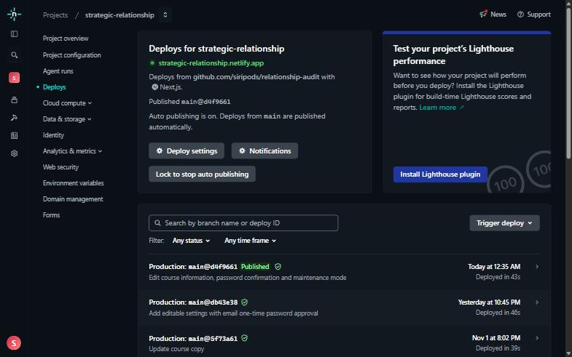
Netlify, Deploys. The "Lock to stop auto publishing" button (method A) is under the text "Auto publishing is on". Each row is one deploy, and the latest is marked Published.
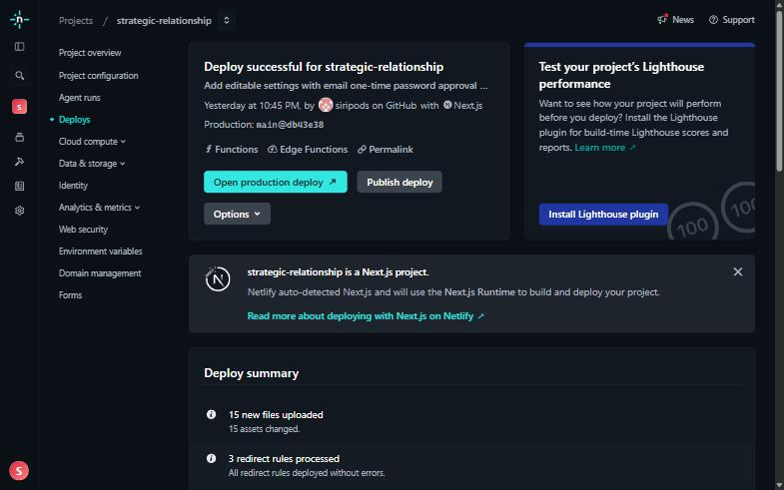
Open an older, successful deploy and press "Publish deploy" to roll back (method B). Do not press it unless you mean to replace the live site.
Never do these to "stop" the application: delete the Netlify site, delete the Neon project or database, or delete responses. They cannot be undone and they destroy evidence you will need.

1.3 Fix the problem while it is stopped
- Write down the time, what you saw, and what you stopped. This helps the developer and any later review.
- Find the cause: the failing deploy's build log (Netlify, Deploys), the function logs (Netlify, Logs), and the Neon dashboard for database errors. Section 11 lists common symptoms.
- Make the fix. A code fix is made by a developer, who tests it on a local copy first (section 9, "Run a local copy for a developer") and then pushes it to main. A settings fix is made in the backoffice.
- Do not restart until the cause is understood. Restarting a cause you have not found usually brings the same fault back.

1.4 Start up again, in this order
- Restore variables. Put back ADMIN_PASSWORD and DATABASE_URL with the same value for all deploy contexts and the default All scopes (section 4). If a secret leaked, use new values, never the old ones.
- Start auto publishing again in Netlify, Deploys.
- Deploy. Move release to the fixed commit with git push origin main:release, or press Trigger deploy, then Deploy project. Wait until the deploy shows Published. The production build also brings the database tables up to date.
- Check it works (all five, in order):
  - The landing page opens, and the banner returns to it from any page.
  - The quiz starts and shows question 1.
  - The backoffice login works and the report loads, which proves the database is reachable.
  - A saved results link opens and shows the courses.
  - A saved result that is flagged for safety shows helplines and no courses. Ask a developer for a test link to keep for this check, and never finish the quiz yourself just to test, because that saves a real row.
- Record the end. Note the time the site was healthy again and what was changed.
Credits. A stop, fix and start cycle can use several deploys at 15 credits each. Check the remaining credits (section 5) so that an emergency does not run out of them.
Outages you cannot fix. If Netlify or Neon is down, nothing in your settings is wrong. Do not change variables or passwords while waiting. Check each service's status page, and test the site again when they report recovery.

1.5 Turning maintenance mode on and off
Maintenance mode closes the public site while you work. Visitors see a Thai page that says the system is closed temporarily and lists the helplines 1300, 1323 and 191. Saving a quiz is refused, so nothing is written to the database. The backoffice and its login keep working, so you can still read reports and edit settings.
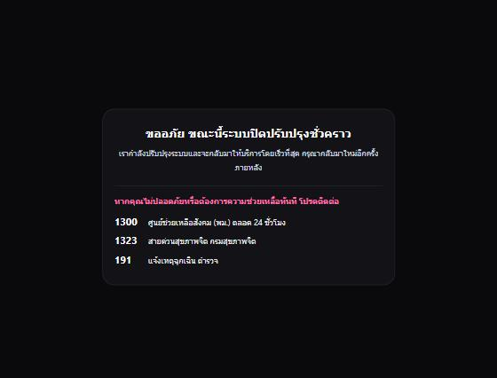
The maintenance page. It has no scripts or outside files, so it still works when the rest of the site does not.
To turn it on
- Open Netlify and your site, then Project configuration, then Environment variables.
- Add a variable named MAINTENANCE_MODE with the value on. Keep the default All scopes and Same value for all deploy contexts.
- Open Deploys, press Trigger deploy, then Deploy project. If publishing is locked, unlock it first, because a locked site builds but does not go live.
- Wait until the deploy says Published.
- Open the site in a private window and confirm you see the maintenance page. Then open /backoffice and confirm you can still log in.
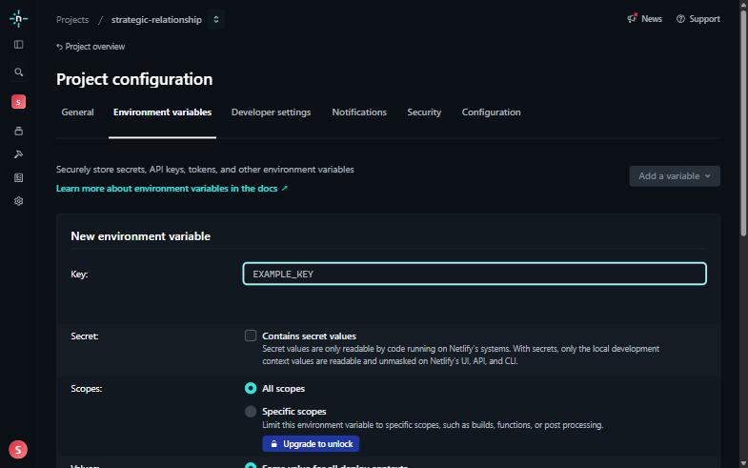
Add a variable, then Add a single variable. Type the name in the Key box (for example MAINTENANCE_MODE). Keep All scopes selected.
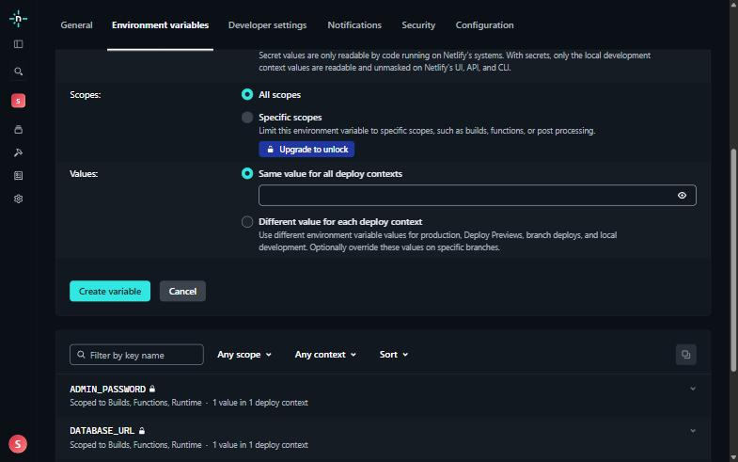
Further down the form: type the value (on) under Same value for all deploy contexts, then press Create variable. Cancel closes the form without saving.
To turn it off
- In Environment variables, delete MAINTENANCE_MODE or set it to off.
- Trigger another deploy and wait for Published.
- Run the five checks in 1.4 before you tell anyone the site is open.
Each change takes a few minutes and uses 15 credits. If the situation cannot wait, use methods A to D first. The page is served with a "try again later" status, so search engines treat the closure as temporary.

2. Overview
The Strategic Relationship Audit is a Thai-language, 10-question relationship quiz that runs on three free services, and this manual covers everything an administrator does on them. The public site and the backoffice are one Next.js application. Netlify runs it, Neon stores the answers and settings, and GitHub holds the source.
Part | What it does | Where you manage it
Public site | Landing page, quiz (10 questions), results page with courses | Live at https://strategic-relationship.netlify.app/
Backoffice | Statistics per question (numbers or pie charts, for all time or a period), usage by date with a line chart, settings (LINE link, course information) | https://strategic-relationship.netlify.app/backoffice
Netlify | Builds and hosts the application, holds the secret settings | Netlify dashboard, site "strategic-relationship"
Neon | PostgreSQL database relationship-audit (Singapore, PostgreSQL 18.6) | Neon console, organization Siripod
GitHub | Source code. Work is saved on main; every push to release deploys to the live site | Repository siripods/relationship-audit (private)
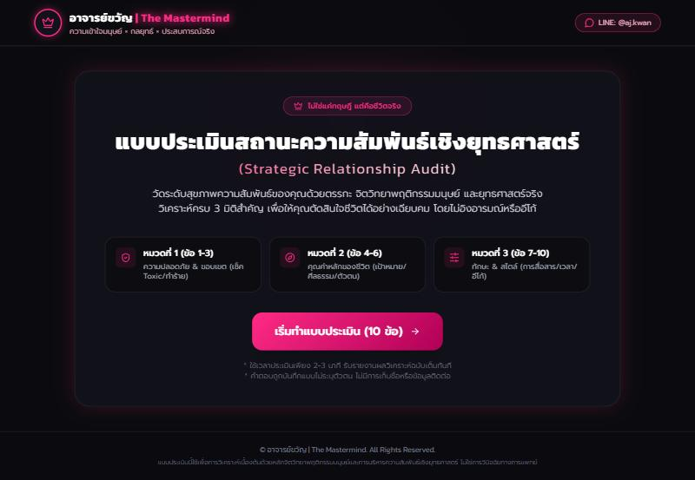
The public landing page. The banner at the top left returns here from every page, and the LINE button is at the top right.
What an administrator does. Day to day, you use the backoffice to read results and to edit the LINE link and course text. Occasionally you use Netlify (variables, deploys) and Neon (database health, backups). You never need to edit code for routine content changes.
How a change reaches visitors.
- Content edits (LINE link, course text) are saved in the backoffice and shown on the site within minutes, with no deploy.
- Code changes are saved on main. Moving release to a chosen commit (git push origin main:release) makes Netlify build and publish them. Each deploy uses 15 of the free plan's 300 credits.
- Secret settings (DATABASE_URL, ADMIN_PASSWORD) are changed in Netlify and need a new deploy to take effect.
- Every successful settings change also sends a warning email to the administrator, so a change nobody made is noticed (section 8.6).
The sections below follow that order: accounts, variables, Netlify, Neon, backoffice, settings, routine checklists, data and privacy, troubleshooting and security.

3. Accounts, access and secrets
Three accounts run the system (a fourth, Resend, is needed only for the warning email), and two secrets protect it (a third, the Resend key, if you use the warning email). Keep the accounts under an owner you control, and share secrets only with people who administer the site.
Account | Used for | Who needs it
Netlify | Hosting, deploys, environment variables, credit usage | The technical administrator
Neon (organization Siripod) | Database, backups, SQL editor | The technical administrator
GitHub (siripods) | Source code and the deploy trigger | The developer who changes code
Backoffice login | Reports and settings. Username admin, password = ADMIN_PASSWORD | Anyone who reads reports or edits content
Resend (optional) | Sending the warning email after settings changes. Dashboard: API keys, domains, logs | The technical administrator
Where each secret lives
Secret | Stored in | Never put it in
DATABASE_URL (Neon connection string with a password inside) | Netlify environment variables; your local .env file for a local copy | Git, chat, screenshots
ADMIN_PASSWORD | Netlify environment variables; your local .env file | Git, chat, screenshots
RESEND_API_KEY (optional) | Netlify environment variables; your local .env file if you test email locally | Git, chat, screenshots
The file .env is ignored by Git on purpose. Only .env.example, which has no real values, is committed.
Rules of thumb
- Use a long, unique password for ADMIN_PASSWORD, and store it in a password manager.
- The backoffice password is asked twice in practice: once at login, and again each time you save a setting, unless two-factor authentication is on, when an emailed code replaces it.
- If anyone who knew the password leaves the team, change it (section 9, "Change the administrator password").
- If a connection string is ever exposed, reset the database password in Neon and update DATABASE_URL in Netlify (section 6).
- A .env file created by the Neon command-line tool points at the live database. Treat it as production, and do not run local tests against it.
- Read every warning email. If you did not make the change, close the site (section 1.5) and change the password (section 9) before doing anything else.

4. Environment variables
The application needs two environment variables, plus two optional switches (MAINTENANCE_MODE and TWO_FACTOR_AUTHEN), three optional settings for the warning email and optional limits for one-time codes and for wrong passwords. All are set in Netlify, and all need a new deploy after any change.
Variable | Purpose | Value | If missing or wrong
DATABASE_URL | Connection to the Neon database | Neon's pooled connection string (the host name contains -pooler) | Pages that read the database fail. The results page returns an error and the build's database step fails
ADMIN_PASSWORD | Password for the backoffice and for confirming settings changes | A long, unique password | Missing: the backoffice returns 503. Wrong password typed: 401 at login, or a refusal on the settings form
MAINTENANCE_MODE (optional) | Closes the public site with a Thai maintenance page | on to close the site. Leave it out, or use off, for normal operation | Missing is normal: the site is open. A value other than on, true or 1 also leaves the site open
ADMIN_EMAIL (optional) | Receives the warning email after every settings change | Your own email address. It can only be set here, never in the app | No email is sent and the Settings page says so. Saving still works
RESEND_API_KEY (optional) | Lets the site send email through your Resend account | The API key from the Resend dashboard, which starts with re_. It is a secret | Missing: no email is sent. Wrong: Resend refuses it and the Settings page shows a warning
EMAIL_FROM (optional) | The sender address of the warning email | onboarding@resend.dev for a test, or an address on a domain verified in Resend | Missing: no email is sent. Not allowed by Resend: the Settings page shows a warning
TWO_FACTOR_AUTHEN (optional) | Makes every settings change need an emailed one-time code instead of the password | on to switch it on. Leave it out, or use any other value, for normal operation. Only after the warning email works | Missing: the password is asked instead. On with email not set up: saving is refused
OTP_TTL_MINUTES, OTP_MAX_REQUESTS, OTP_REQUEST_WINDOW_MINUTES (optional) | Limits for the one-time codes | Lifetime in minutes (default 10), codes that may be requested (default 3) and the window for that limit in minutes (default 15) | Missing or invalid values use the defaults
OTP_MAX_ATTEMPTS (optional) | Wrong tries allowed for each one-time code | A whole number from 1 to 10. The default is 5 | Missing or invalid values use 5. After the last wrong try the code is cancelled
PASSWORD_MAX_ATTEMPTS, PASSWORD_LOCK_MINUTES (optional) | Limit on wrong administrator passwords on the settings forms, used while two-factor is off | Wrong passwords allowed in a row, from 1 to 20 (default 5), and the minutes saving stays locked afterwards, from 1 to 1440 (default 15) | Missing or invalid values use the defaults. See section 8.8
Setting a variable in Netlify. Open the project, then Project configuration, then Environment variables, then Add a variable, then Add a single variable. Type the name and the value, and keep the default All scopes (it includes Functions, which the backoffice needs) and Same value for all deploy contexts. Press Create variable. After saving, start a new deploy: Deploys, Trigger deploy, Deploy project.
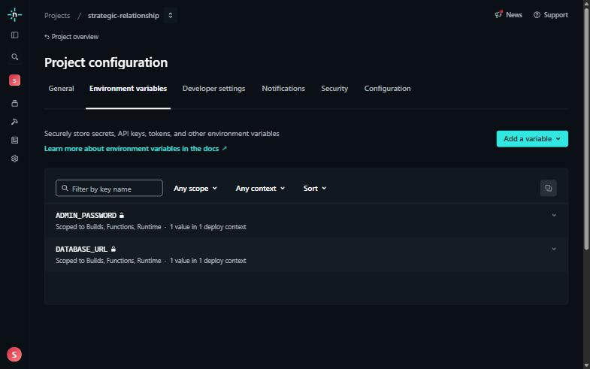
Project configuration, Environment variables. The page lists the names only. The values stay hidden, and each one is applied to all scopes.
Why the pooled string. Neon puts the database to sleep after 5 minutes without use and drops idle connections. The pooled string and the small connection pool in lib/db.ts cope with this. A direct (non-pooled) string can run out of connections under load.
Local copy. A developer running the app on a computer copies .env.example to .env and fills in the same two names, pointing DATABASE_URL at a local database, never at production.
Warning email (optional). ADMIN_EMAIL, RESEND_API_KEY and EMAIL_FROM switch on the email sent to the administrator after every settings change (section 8.6). They also send the one-time codes when two-factor authentication is on (section 8.7). Without all three, saving still works while two-factor authentication is off, and the Settings page says no email was sent.

5. Netlify administration
Netlify builds the application from the release branch of the GitHub repository and serves it at https://strategic-relationship.netlify.app/. Work and documents are saved on main, which Netlify ignores: the site changes only when release moves. The build is described in netlify.toml, so the dashboard needs almost no settings.
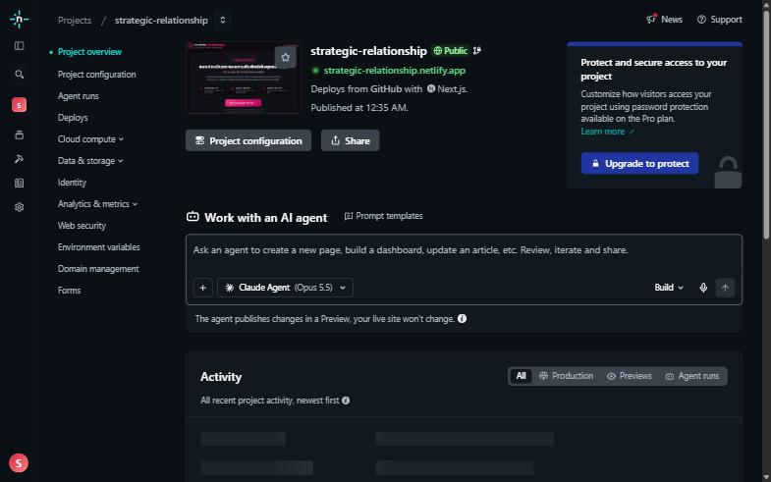
The project overview. The menu on the left has Deploys, Project configuration, Environment variables and Domain management.
Build configuration (in netlify.toml)
Item | Value | Meaning
Node version | 22 | Used for every build
Normal build | npm run build | Used for previews and branches
Production build | npm run db:migrate && npm run build | On live deploys, first brings the database schema up to date and adds any missing course rows, then builds
The database step is safe to repeat. It never deletes responses and never overwrites course text you have edited.
Deploys and credits
- Every push to release starts a deploy, and each deploy uses 15 of the free plan's 300 credits per month. Pushes to main cost nothing. Group changes into one push.
- A commit that only changes documents should contain [skip netlify] and go to main only, so it never deploys. The newest commit you push to release must not contain it, or Netlify skips that deploy.
- Check remaining credits in the Netlify dashboard under the team's usage or billing page. If credits run out, the site can stop serving until the next cycle or until you upgrade, so look at it before a busy campaign.
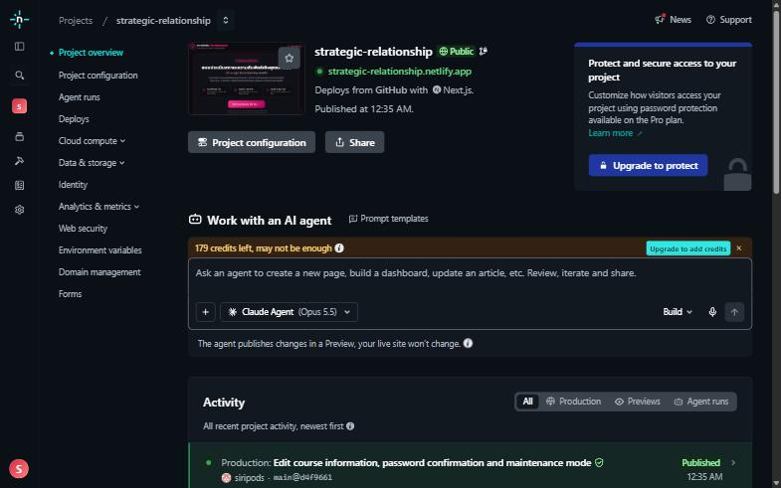
The project overview. The banner at the top of the box shows the credits left (here 179). Check it before a busy period and after a series of deploys.
Common Netlify tasks
Task | Where | Notes
See whether a deploy worked | Site, Deploys | Open the latest deploy to read its build log. Failures show in red
Redeploy without a code change | Deploys, Trigger deploy, Deploy project | Needed after changing an environment variable
Roll back a bad release | Deploys, choose an older successful deploy, Publish deploy | Restores the old code only. The database is not rolled back
Change an environment variable | Project configuration, Environment variables | Then trigger a deploy
Read runtime errors | Logs, Functions (or the deploy's function logs) | Useful for a page that returns 500
Custom domain | Domain management | Netlify provides HTTPS certificates automatically
Stop automatic deploys | Deploys, Stop auto publishing | Lets you build without going live. Turn it back on afterwards
Publish the latest work | Terminal, in the project folder | git push origin main:release moves release to the tip of main and starts one deploy. Compare the live deploy on Deploys with git log release -1
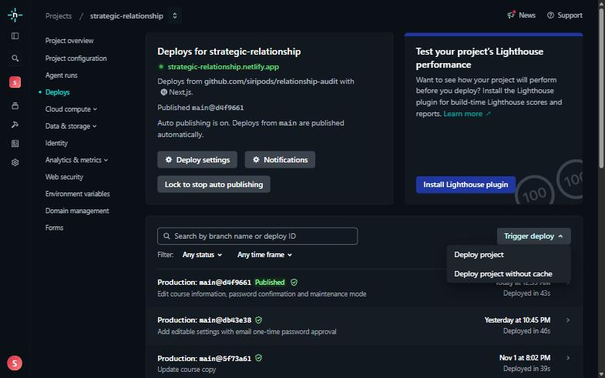
The Trigger deploy menu on the Deploys page. Choose Deploy project to build the latest code again. Deploy project without cache is for a stubborn build problem.
Checking the live site without saving data
Send an invalid request and expect a refusal, rather than finishing the quiz (which saves a real row). A request to /api/responses with invalid content should return 400. A request to /results/ with an unknown ID should return 404, which also proves the database connection works.
Limits of the free plan to remember: monthly credits (builds and traffic both draw on them), no guaranteed support, and a build needs internet access to download Google Fonts.

6. Neon administration
Neon hosts the PostgreSQL database. The project is relationship-audit (ID lingering-band-55049917) in organization Siripod, region Singapore (aws-ap-southeast-1), PostgreSQL 18.6. The application stores everything in two tables.
Table | Holds | Written by
responses | One anonymous row per finished quiz: the 10 answers, scores, band, safety flag, time | The quiz
settings | The LINE link (line_url) and one row per course (course:conquer, course:bedfire, course:getback) | The backoffice settings pages and the deploy's database step
Behaviour you should expect
- Sleep. On the free plan the database suspends after about 5 minutes without queries. The first request after a pause can take a second or two longer while it wakes. This is normal.
- Connection string. Use the pooled string for DATABASE_URL. Find it in the Neon console under your project, Connect, and choose the pooled option.
- Encoding. The database is UTF8, which is required for Thai text in course information. Do not create a replacement database with another encoding.
- Schema changes. Never edit tables by hand for schema changes. They are added to db/schema.sql in a repeatable form and applied by the production build.
Common Neon tasks
Task | Where | Notes
Look at data or run a query | Project, SQL Editor | Read-only queries are safe. Be careful with UPDATE and DELETE
See how big the database is and how busy | Project dashboard and Monitoring | Watch storage and compute hours against the free plan limits
Undo a mistake in the data | Project, Backup and Restore (history restore) | The free plan keeps a short history window only, so act quickly. Check the current limit on Neon's plan page
Try a risky change safely | Project, Branches, create a branch | A branch is a copy you can test on without touching production
Replace a leaked password | Project, Roles, reset password for the role | Then copy the new pooled string into DATABASE_URL in Netlify and redeploy
Export everything | See section 10 | Use pg_dump with the direct connection string
Useful read-only queries (SQL Editor)
-- How many quizzes were completed, and when was the latest
SELECT count(*), max(created_at) FROM responses;
-- Which settings and courses are stored, and when each was last saved
SELECT key, updated_at FROM settings ORDER BY key;
If the free storage or compute limit is reached, Neon may pause the project until the next cycle, and the site will then show database errors. Check the dashboard now and then, and upgrade the plan if traffic grows.

7. Backoffice
The backoffice is the administrator's workspace, and it only shows aggregated, anonymous information. Open /backoffice on the live site. The browser asks for a username and password: use admin and the value of ADMIN_PASSWORD.
Login notes
- There is no logout button. The browser remembers the login until you close it. On a shared computer, use a private window and close it afterwards.
- A 503 page means ADMIN_PASSWORD is missing in Netlify. A repeated login prompt means the password is wrong.
- Backoffice pages are hidden from search engines.
Menu. The menu at the top has three items, and the tab you are on stays highlighted: สถิติรายข้อ (Statistics per question), การใช้งาน (Usage) and ตั้งค่า (Settings). สถิติรายข้อ has a sub menu, "แสดงแบบ", to choose between the numbers (ตัวเลข) and a pie chart per question. The banner at the top left of every page returns to the landing page.
Page | What it shows | What it does not show
สถิติรายข้อ: ตัวเลข | For each of the 10 questions: how many times each answer was chosen, and the percentage, for all time or a chosen period | Which person gave which answer
สถิติรายข้อ: Pie chart | The same statistics, with the same period choice, as a pie chart per question | Anything beyond the report's counts
การใช้งาน Usage | A line chart and a table of completed quizzes per day for a date range you choose, or a quick link for the last 7, 30, 90 or 365 days. Days follow Thai time (Bangkok) | People who opened the quiz but did not finish. Quiz starts are not recorded
ตั้งค่า Settings | The LINE link and the course information, each editable (next section) | Any personal data
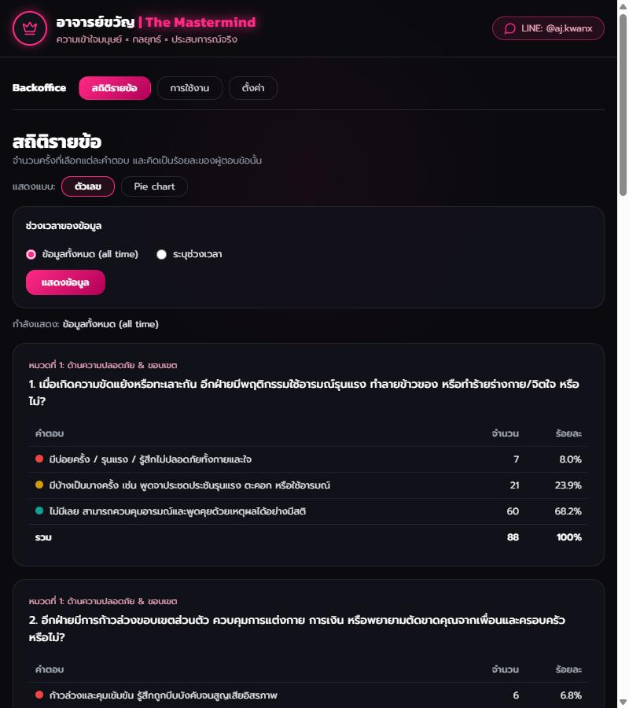
สถิติรายข้อ, numbers view: each question with how many times each answer was picked, and the percentage. The sub menu and the period choice are above the tables.
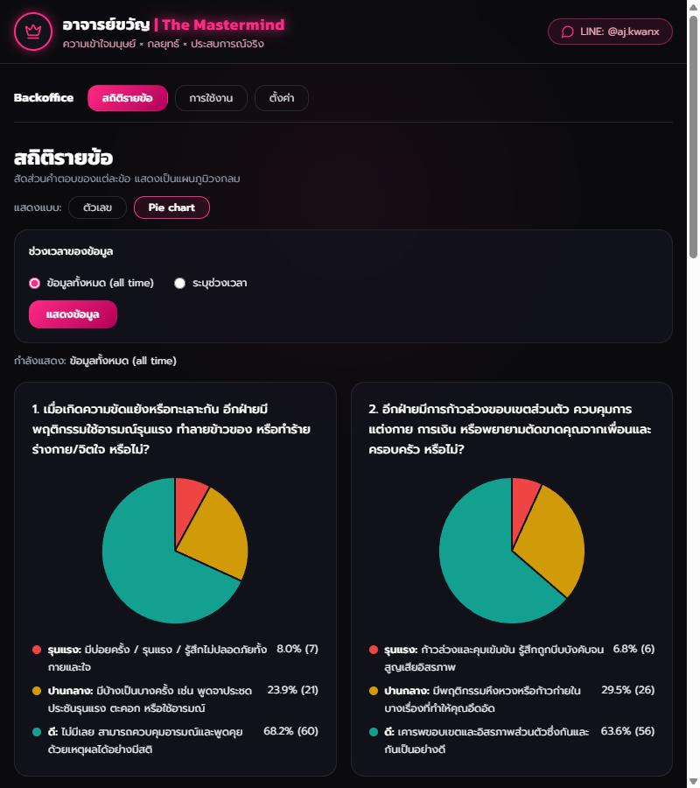
สถิติรายข้อ, Pie chart view: the same statistics as one pie chart per question, with the same period choice.
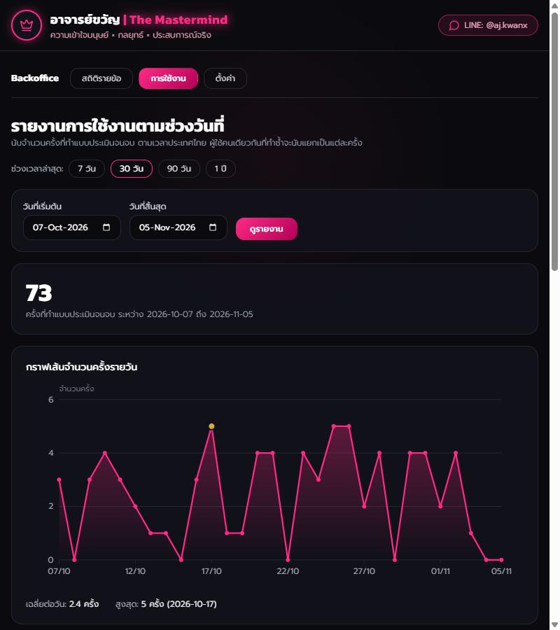
Usage: choose a start and end date or a quick range, then read the total, the line chart and the count per day.
Reading the usage report. Pick a start and end date and press the show button, or press 7 วัน, 30 วัน, 90 วัน or 1 ปี. The line chart shows one point per day, with the busiest day in gold, and hovering over a day shows its count. Under the chart are the daily average and the highest day. The report counts one per finished quiz. It cannot tell two visits by the same person apart, because no identity is stored.
Reading the report. Percentages are calculated from the answers saved so far, and they recalculate whenever the page is opened. The first option of each question is the most severe (red), the second is yellow and the third is green.
Choosing the period. Both views of สถิติรายข้อ start with all the data (all time). Choose "ระบุช่วงเวลา" to show the start and end date boxes, pick the dates and press "แสดงข้อมูล". The line under the form says what is being shown. The choice stays when you switch between the numbers and the pie charts, and it is part of the address, so you can bookmark it. Days follow Thai time, and a period of any length is accepted. A mistake in the dates shows a red message and no data.

8. Backoffice settings
The Settings page changes what visitors see, with no developer and no deploy. It holds two things: the LINE link, and the information of each course. Every save asks you to type the administrator password again (or, with two-factor authentication on, to enter an emailed code), which protects the site if a logged-in browser is left unattended.

8.1 How saving works
- Change the fields and type the administrator password in the "รหัสผ่านผู้ดูแล" box.
- Press "บันทึก" (Save). A wrong password shows a red message with the tries left, and changes nothing. A pause of one second follows each wrong attempt. After 5 wrong passwords in a row, saving is locked for a while (section 8.8).
- The password box empties after every attempt, whether it worked or not.
- A green message confirms the save, and a second message says whether the warning email was sent (section 8.6). Visitors see the change at once, or within 5 minutes at most, because public pages are cached briefly.
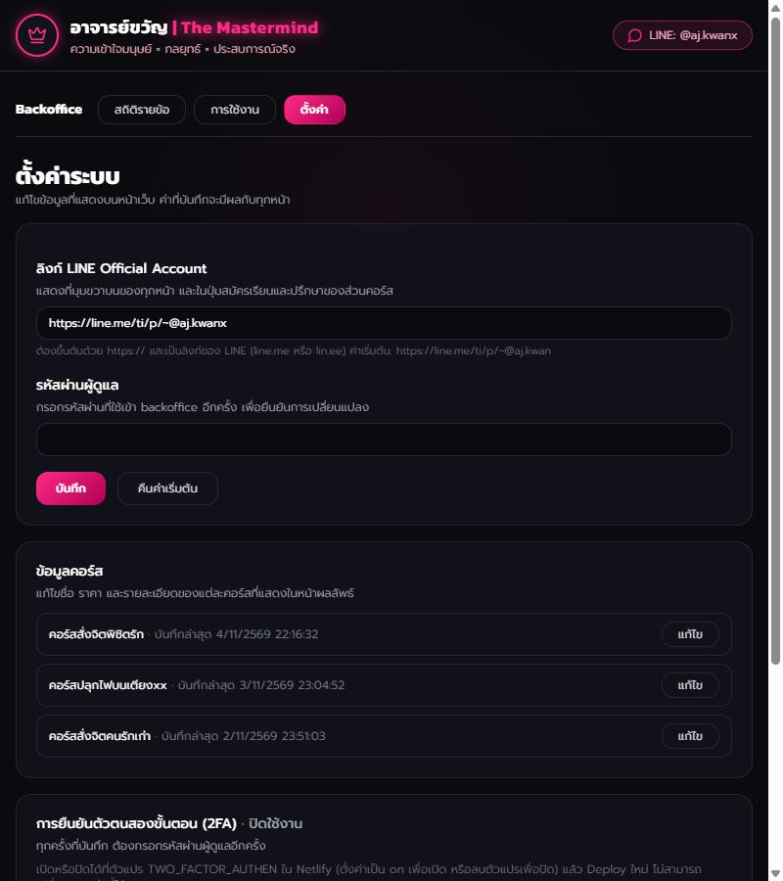
The top of the Settings page: the LINE link, the administrator password box, and the Save and Reset buttons.
"คืนค่าเริ่มต้น" (Reset) puts the built-in value back. It needs the password too.

8.2 The LINE link
The link appears at the top right of every page, and inside the sign-up and consultation buttons of the course section. The account name shown beside it (for example LINE: @aj.kwan) is worked out from the link. Short links such as lin.ee show LINE Official instead.
Rule | Detail
Starts with | https://
Allowed sites | line.me or lin.ee only
Length | Up to 300 characters, no spaces
Built-in value | https://line.me/ti/p/~@aj.kwan
The rules exist because the link is used on every page. Anything else is refused.

8.3 Course information
The Settings page lists the three courses with their last saved time. Press "แก้ไข" (Edit) beside one to open its form. All fields accept Thai and English.
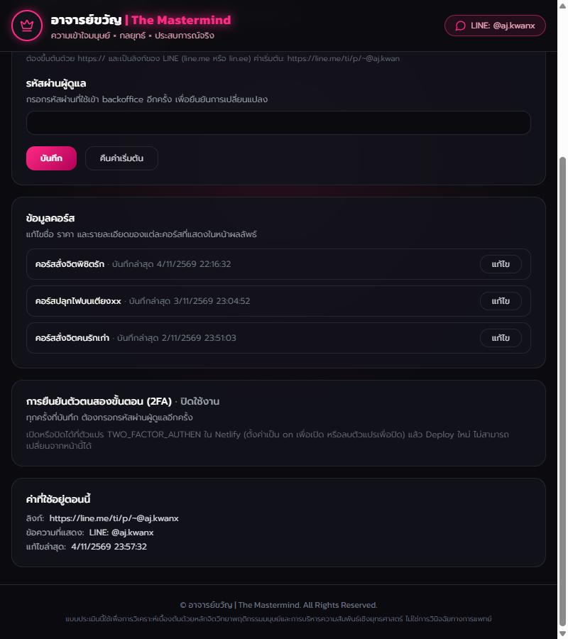
The course list at the bottom of the Settings page. Each course has an Edit button and its last saved time. Below the list are the two-factor authentication status and the current values.
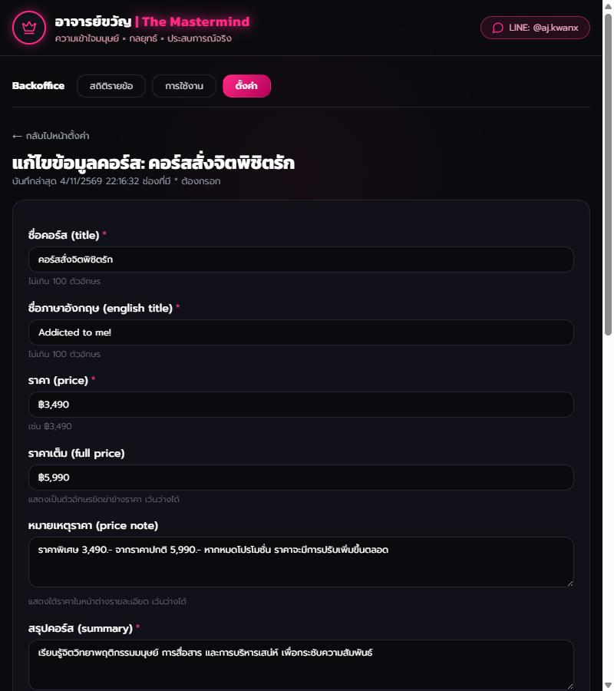
A course's edit form. Required fields carry a pink star, and the password box sits at the bottom with the Save and Reset buttons.
Field | Shown where | Required | Limit
Title | Course card and details window | Yes | 100 characters
English title | Pink label on the card and in the window | Yes | 100 characters
Price | Gold price on the card and in the window | Yes | 30 characters
Full price | Crossed-out price beside the price | No | 30 characters
Price note | Small text under the price in the window | No | 500 characters
Summary | Short description on the card and in the window | Yes | 500 characters
Details | Checklist "what you will learn" in the window | Yes, at least one | 20 lines, 300 characters each
Modules | Pinned list under the details | No | 20 lines, 300 characters each
Benefits | Gold box with star items | No | 20 lines, 300 characters each
Suitable | Italic box at the bottom of the window | No | 1,000 characters
Tips
- For Details, Modules and Benefits, write one item per line. Blank lines are ignored.
- A field left blank (when optional) disappears from the page.
- The price note is separate text. When you change a price, also check the price note, because it may still quote the old number.
- If a field is invalid, the form keeps everything you typed and marks the field in red, so nothing is lost.
- Text is shown exactly as typed. HTML tags are shown as plain text, not run.
- The courses and their order are fixed. You edit the three existing courses but cannot add or delete one.

8.4 Where course text comes from
Each course is stored as one row in the database. Every production deploy adds a row for any course that has none, using the built-in text from the code, and never touches a row that already exists. So after the first deploy the database is the source of truth, and the backoffice is the place to edit. A change to the built-in text in the code does not alter a course that already has a row. Use Reset on that course to bring the built-in text back.

8.5 What an edit can never change
The safety rule is built into the application, not into the settings. If a person's answers to any of questions 1 to 3 are the most severe, the results page shows helplines and hides all courses and consultation offers, whatever the course settings say. Never ask a developer to weaken this rule.

8.6 The warning email
Every successful save or reset of the LINE link or a course sends an email to ADMIN_EMAIL. Its purpose is to tell you at once when something on the site was changed, so that a change you did not make is noticed within minutes. The email is sent after the change is saved, so it can never block or undo a save.
What the email contains
Part | Content
Subject | A warning label, what was changed (the LINE link or the course name) and the time in UTC
Time | Bangkok time and UTC
Action | Save, or Reset
Changes | Each changed setting with its value before and after. Long text is cut at 200 characters. A save that changed nothing says so
Request details | The IP address and browser of whoever made the change. They are in the email only and are not stored
Warning | If you did not make the change, the web site may be under attack or hacked. Shut it down temporarily and investigate
Steps | Close the site, change the password, restore the values, check the logs, reopen
The email never contains the password.
What the Settings page tells you. Under the green confirmation, a second message says one of three things: the email was sent; it failed (Resend refused it or could not be reached; check the three variables and Resend's Logs page); or it is not set up (one of ADMIN_EMAIL, RESEND_API_KEY or EMAIL_FROM is missing). In every case the change itself was saved. A wrong password changes nothing and sends nothing.
If you get a warning you did not expect
- Do not ignore it. Close the site with maintenance mode (section 1.5).
- Change ADMIN_PASSWORD and redeploy (section 9), so the person who made the change is locked out.
- Open Settings and check the LINE link and every course. The email shows the old values, so you can retype them, or press Reset to put the built-in text back.
- Look at Netlify's Deploys and Neon's monitoring for anything you do not recognise.
- When you are sure the site is safe, reopen it.
Setting it up. Add the three variables in Netlify as described in section 4, then redeploy. You need a Resend account (resend.com) and an API key. For a first test, set EMAIL_FROM to onboarding@resend.dev and ADMIN_EMAIL to the email you signed up to Resend with: Resend delivers that test sender's email only to that address. To send from your own address, open Domains in Resend, add a domain you own, add the DNS records it shows at your registrar, wait until it says Verified, then set EMAIL_FROM to an address on that domain and redeploy. The Installation Manual has the step-by-step version.
Limits. Email delivery is not guaranteed, and Resend's free plan has sending limits, so a missing email does not prove that nothing changed. The warning covers changes made through the Settings page only, not changes made directly in Neon or Netlify, and failed password attempts are not reported. It also cannot help if someone controls the mailbox or the Netlify variables.

8.7 Two-factor authentication
Two-factor authentication replaces the typed password with a code emailed to ADMIN_EMAIL. It is switched with the TWO_FACTOR_AUTHEN variable in Netlify, not on the Settings page, so that someone who stole the backoffice password cannot switch it off. The Settings page shows whether it is on.
 | Off (the default) | On
Password box on the forms | Shown | Replaced by a note
After pressing Save | The change is applied at once | A code is emailed, the page asks for it, and the change is applied only when it is entered
If email cannot be sent | Saving works and only the warning is skipped | Saving is refused with a message
Entering the code. The code page lists what will change, with the old and new values. Enter the 6 digits and press the confirm button (ยืนยัน). A wrong code shows how many tries are left (5 per code by default; the last wrong try cancels the code and you start again from Settings). A code lasts 10 minutes and works once. Send a new code (ส่งรหัสใหม่) makes the old one stop working, and cancel (ยกเลิกการเปลี่ยนแปลง) drops the change.
Limits. At most 3 codes can be requested in 15 minutes, in total. Every edit needs its own code, so editing more than three courses in a row is refused with a message until the time passes. Raise OTP_MAX_REQUESTS if that gets in the way.
If you are locked out. With two-factor on and email not working, nobody can save settings. The site itself keeps running. Fix the email variables, or remove TWO_FACTOR_AUTHEN, and redeploy (section 9).
Good habits. Protect the mailbox of ADMIN_EMAIL with two-step verification, because it now approves every change. Never read a code to anyone. A code email you did not ask for means someone who knows the backoffice password tried to change a setting: change the password (section 9) and follow section 8.6.

8.8 Wrong password lock
While two-factor authentication is off, the settings forms stop guessing of the administrator password. The count is shared by everyone, so it does not depend on which computer is used.
 | What happens
Wrong password 1 to 4 | A red message says how many tries are left. Nothing is saved
Wrong password 5 | Saving is locked for 15 minutes. The message gives the time it works again, and you receive one warning email with the time, the IP address and the browser
During the lock | Even the right password is refused. Both settings pages show a yellow banner with the time. Reading pages and the public site still work
After the lock | It ends by itself. A correct password starts the count again
The limits are PASSWORD_MAX_ATTEMPTS (default 5) and PASSWORD_LOCK_MINUTES (default 15), set in Netlify (section 4). Typing wrongly yourself is harmless: wait for the time in the message. If you did not type the passwords, someone who can open the backoffice is guessing: change ADMIN_PASSWORD (section 9) and follow section 8.6. To unlock at once, run DELETE FROM password_failures; in Neon's SQL Editor (section 6).
The lock covers the settings forms only. The backoffice login prompt has no limit, so keep ADMIN_PASSWORD long and unique. With two-factor on, this lock is not used and the one-time password limits apply instead.

9. Routine tasks
Each checklist below is complete on its own. The first three need only the backoffice.

Change the LINE link
- Open /backoffice, then Settings.
- Replace the link in the LINE field with the new https://line.me/... or https://lin.ee/... link.
- Type the administrator password and press Save.
- Open the landing page in a private window and check the top-right button and a course sign-up button.

Change a course price or description
- In Settings, press Edit beside the course.
- Change the field. If you change the price, also change the price note and full price if they quote it.
- Type the administrator password and press Save.
- Finish a quiz that is not flagged for safety, or open an existing results link, and check the course card and its details window.
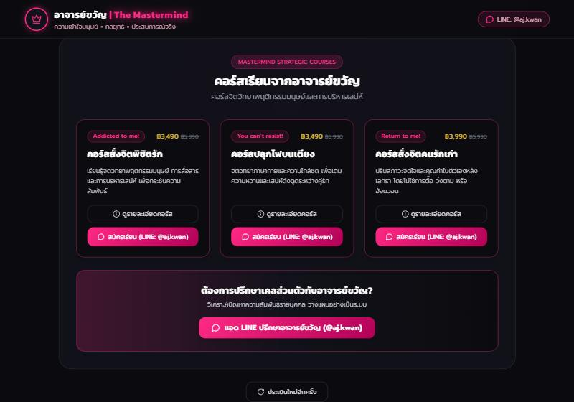
Check the result: the course cards on a results page show the new price and text.

Undo a course edit
- Open the course's Edit page and press Reset to put the built-in text back, or retype the earlier text and Save.
- There is no history of earlier edits. Keep a copy of important text elsewhere before replacing it.

Change the administrator password
- In Netlify, open Project configuration, then Environment variables.
- Edit ADMIN_PASSWORD, keep the default All scopes, and save.
- Open Deploys, then Trigger deploy, then Deploy project, and wait for it to publish.
- Close every browser window that was logged in, then log in again with the new password.
- Tell every other administrator the new password through a safe channel.

Test the warning email
Do this after setting up the email, and every few months.
- In Settings, press Edit beside a course, change nothing, type the administrator password and press Save.
- Check that the page shows the green confirmation and a second message saying the email was sent.
- Within a minute an email should arrive at ADMIN_EMAIL (look in spam the first time). It should say that no value changed.
- If it does not arrive, see section 11.

Turn two-factor authentication on or off
To turn it on:
- Test the warning email first (the task above). Two-factor needs working email.
- In Netlify, open Project configuration, then Environment variables, and add TWO_FACTOR_AUTHEN with the value on. Keep All scopes.
- Open Deploys, then Trigger deploy, then Deploy project, and wait until it shows Published.
- Open Settings. It should say two-factor authentication is on, and the password box should be gone.
- Make a harmless edit: save a course without changing anything, then enter the code from the email.
To turn it off, delete TWO_FACTOR_AUTHEN in Netlify, deploy again, and check that the password box has returned.

Check that the site is healthy (monthly, or before a campaign)
- Open the landing page and the quiz, and confirm the start button works.
- Log in to the backoffice and confirm the report loads (this proves the database is reachable).
- In Netlify, confirm the latest deploy shows as published, and note the remaining credits.
- In Neon, confirm the project is active and storage is well below the free limit.
- Open Usage for the last 30 days and compare it with what you expect.

Run a local copy for a developer
To try changes before they go live, a developer needs Node 18.17 or newer and runs these commands from a short folder path such as D:\dev\strategic-relationship.
npm install
cp .env.example .env # then set ADMIN_PASSWORD, keep DATABASE_URL local
npm run db:dev # local database, keep it running
npm run db:migrate # create tables and add the course rows
npm run dev # open http://localhost:3000
Never point a local copy at the production database.

10. Data, privacy and backup
The system stores no names, contact details or IP addresses, and administrators must keep it that way. Quiz answers are sensitive, because some people answer while living with violence or control.
What is stored
Data | Stored | Not stored
A finished quiz | Answers to the 10 questions, scores, result band, safety flag, time of saving, a random ID | Name, email, phone, IP address, device details
Settings | LINE link, course text, time last saved | Who saved it
Unfinished quizzes | Nothing | Everything. Quiz starts are not recorded
Results links. Each result has a random, unguessable address (/results/<id>). Anyone who has the link can see that one result, so people should share it only with someone they trust. Results are not listed anywhere public.
Backup and export
- For a quick look, run a query in the Neon SQL Editor, for example SELECT * FROM responses ORDER BY created_at DESC;.
- For a full copy, a developer runs pg_dump with Neon's direct (non-pooled) connection string and keeps the file in a private, encrypted place.
- Neon also keeps a short history that lets you restore the database to an earlier moment. Use it for mistakes made very recently, not as a long-term archive.
pg_dump "<direct connection string>" --no-owner --file=backup-2026-11-02.sql
A backup file holds every response, so treat it as sensitive data.
Deleting data. Normally you never need to. If you must remove responses, for example test rows before launch, use the Neon SQL Editor, check what a query selects before you delete, and make a backup first.
-- Look first
SELECT count(*) FROM responses WHERE created_at < '2026-11-01';
-- Then delete the same rows
DELETE FROM responses WHERE created_at < '2026-11-01';
Deleting a response makes its results link stop working. After a deletion, the report and usage numbers change to match.
Changing questions. Stored answers refer to questions by position only. Rewording or reordering a question changes what old answers mean, and reports recalculate old rows with the new wording. Ask a developer to add a question version before changing questions.

11. Troubleshooting
Start with the symptom, then follow the first likely cause.
Symptom | Likely cause | What to do
Backoffice shows a 503 page | ADMIN_PASSWORD is missing in Netlify, or was changed without a new deploy | Set it in Netlify (section 4), then redeploy
Backoffice keeps asking for the password | Wrong password, or the password was changed without redeploying | Check the value in Netlify and redeploy; try a private window
Settings save says the password is wrong | The password typed differs from ADMIN_PASSWORD | Retype it carefully. Remember the box empties after every attempt
Saved a setting, but the site still shows the old value | Public pages are cached up to 5 minutes | Wait a few minutes and reload; try a private window
Course text shows the old price note | The price note is a separate field | Edit the price note too
A results page or the report shows an error | The database is unreachable, or Neon is waking up | Reload after a few seconds. If it persists, check DATABASE_URL and the Neon project status
First page after a quiet period is slow | Neon wakes from sleep | Normal. Only the first request is slow
Deploy fails in the database step | DATABASE_URL missing, wrong, or the project is paused | Fix the variable or resume the project in Neon, then redeploy
Deploy fails while downloading fonts | Build has no internet access to Google Fonts | Retry the deploy
Site stopped after many deploys | Free credits used up | Wait for the next cycle or upgrade. Group changes in future
A bad deploy broke the site | A code change | Deploys, publish the last good deploy, then ask a developer to fix main
Course edit fails with an encoding error (local copy only) | The local database is not UTF8 | Recreate the local database as UTF8. Neon is already UTF8
The Start button does nothing (local copy only) | The development and production build folders collided | Stop the app, delete the .next-dev folder, start again
Visitors see "closed for maintenance" (503) | MAINTENANCE_MODE is still set to on in Netlify | Delete it or set it to off, then deploy and wait for Published (section 1.5)
Settings page says the warning email failed | A value is wrong, EMAIL_FROM is not on a domain verified in Resend, or (with onboarding@resend.dev) ADMIN_EMAIL is not the email of your Resend account | Check the three variables (section 4), redeploy, and read the reason on Resend's Logs page. The save itself was not affected
Settings page says the warning email is not set up | One of ADMIN_EMAIL, RESEND_API_KEY or EMAIL_FROM is missing, or was added without a new deploy | Add it (section 4) and redeploy
No warning email arrived after a save | It is in the spam folder, a Resend limit was reached, or the Settings page said failed or not set up | Check spam, the second message on the Settings page, and Resend's Logs page
A warning email arrived for a change you did not make | Someone else knows the backoffice password, and the site may be under attack | Follow section 8.6: close the site, change ADMIN_PASSWORD, restore the changed values
With two-factor on, saving says the code could not be sent | ADMIN_EMAIL, RESEND_API_KEY or EMAIL_FROM is missing or wrong | Fix them (section 4) and redeploy, or remove TWO_FACTOR_AUTHEN and redeploy to use the password again
No code email arrives | It is in spam, Resend refused it, or the limit of codes was reached | Check spam, the message on the Settings page and Resend's Logs page, then send a new code
The page says codes were requested too often | More than 3 codes were requested in 15 minutes | Wait 15 minutes, or raise OTP_MAX_REQUESTS (section 4) and redeploy
The code page says the request was used, cancelled or expired | The code is older than 10 minutes, was already used, was replaced by a newer request, or was entered wrongly 5 times | Start again from the Settings page. Nothing was changed
A code email arrived that you did not ask for | Someone who knows the backoffice password tried to change a setting | Share the code with nobody. It expires unused. Change ADMIN_PASSWORD (section 9) and follow section 8.6
Saving says it is locked because of wrong passwords | Five wrong administrator passwords in a row (or the number set in PASSWORD_MAX_ATTEMPTS) | Wait until the time in the message and try again. If you did not type them, change ADMIN_PASSWORD (section 9). To unlock at once, see section 8.8
The code page says the code was cancelled for too many wrong tries | Five wrong codes were typed (or the number set in OTP_MAX_ATTEMPTS) | Start again from Settings. A new code is emailed, within the limit of 3 codes per 15 minutes
When to call a developer: a deploy keeps failing, the database shows errors for more than a few minutes after Neon looks healthy, the site shows someone's results to another person, or anything suggests the safety rule is not working (a flagged result showing courses). Send them the failing deploy's log or the page address.

12. Security practices and glossary
Security practices
- Give each administrator only the access they need, and remove access in Netlify, Neon and GitHub when someone leaves.
- Keep DATABASE_URL and ADMIN_PASSWORD out of Git, chat, email and screenshots.
- Change the administrator password when anyone who knew it leaves, and at least once a year.
- Keep the GitHub repository private.
- Use a private window for the backoffice on shared computers, and close it afterwards.
- Enable two-step verification on the Netlify, Neon and GitHub accounts.
- Keep backup files in a private, encrypted place, and delete the ones you no longer need.
- The site is served over HTTPS by Netlify, and the backoffice must always be opened through the https:// address.
- Do not add names, phone numbers, emails or IP addresses to stored responses, even for convenience.
- Treat RESEND_API_KEY like a password: keep it out of Git, chat and screenshots, and if it is exposed, delete it in the Resend dashboard, create a new one and redeploy.
- Read every warning email the day it arrives, and keep ADMIN_EMAIL pointed at a mailbox protected with two-step verification.
- Turn on two-factor authentication (section 8.7) once the warning email works, and never read a code to anyone: nobody legitimate needs it.
- Keep the wrong-password limits at the defaults or stricter (section 8.8). Treat a warning email about wrong passwords as a sign that someone is guessing, and change ADMIN_PASSWORD.
Glossary
Term | Meaning
Deploy | One build and publish of the site on Netlify
Credit | The free plan's monthly allowance that builds and traffic use up. A deploy uses 15
Environment variable | A secret or setting kept in Netlify, outside the code
Pooled connection string | Neon's connection address that shares connections, which suits a website on Netlify
Scale to zero | Neon putting an unused database to sleep and waking it on the next request
Migration | A safe-to-repeat update of the database tables, run on each production build
Seed | Course text copied from the code into the database, once per course
Safety flag | Set when any of questions 1 to 3 has the most severe answer. It hides all courses
Backoffice | The password-protected administrator area under /backoffice
Maintenance mode | A switch (MAINTENANCE_MODE=on) that closes the public site with a Thai page while the backoffice stays open
Warning email | The email sent to ADMIN_EMAIL after every successful settings change, listing what changed and telling you to shut the site down if the change was not yours
Resend | The email service the site uses to send the warning email
Two-factor authentication | Settings changes need a one-time code emailed to ADMIN_EMAIL, as well as the backoffice login. Switched by TWO_FACTOR_AUTHEN in Netlify
One-time password (OTP) | A 6-digit code, valid 10 minutes and usable once, emailed to approve one settings change
Wrong password lock | Saving is refused for a while after too many wrong administrator passwords in a row. Set by PASSWORD_MAX_ATTEMPTS and PASSWORD_LOCK_MINUTES
Period (statistics) | The choice on สถิติรายข้อ between all the data (all time) and a range of days

